# Moving from binary to multi-class classification

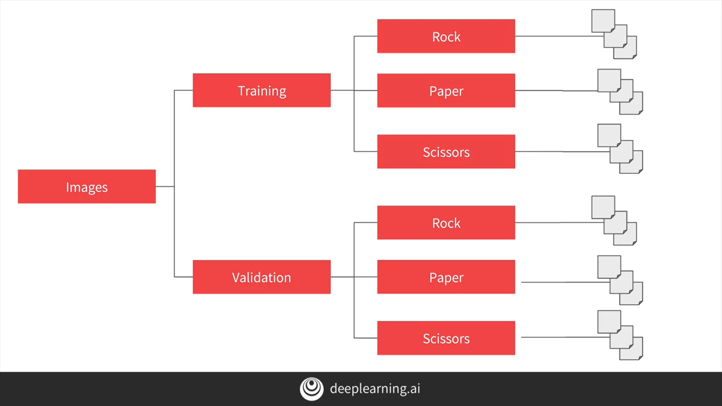

# Explore multi-class with Rock Paper Scissors dataset

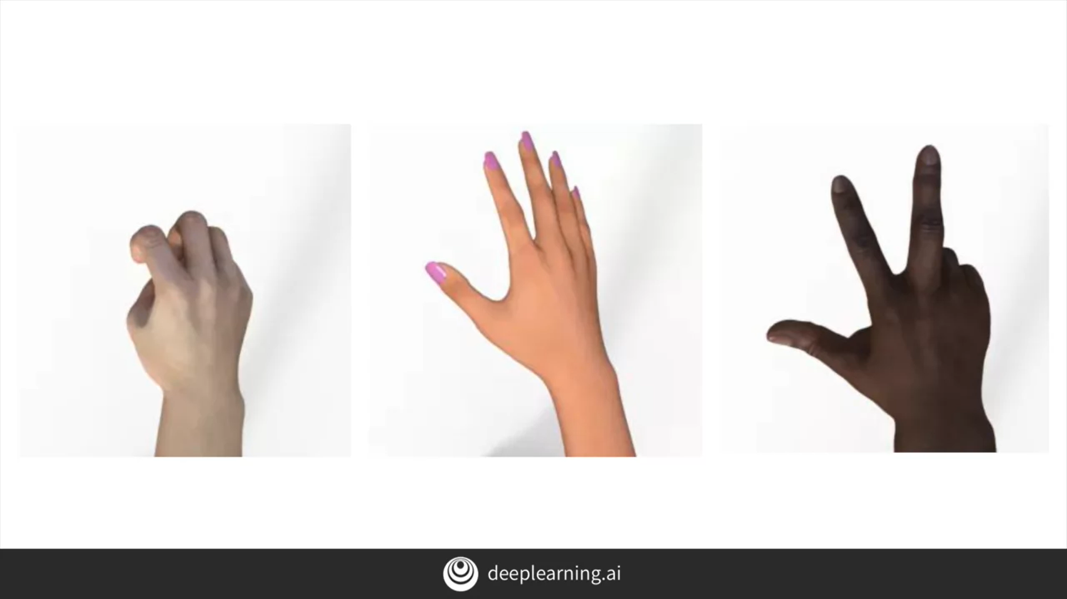

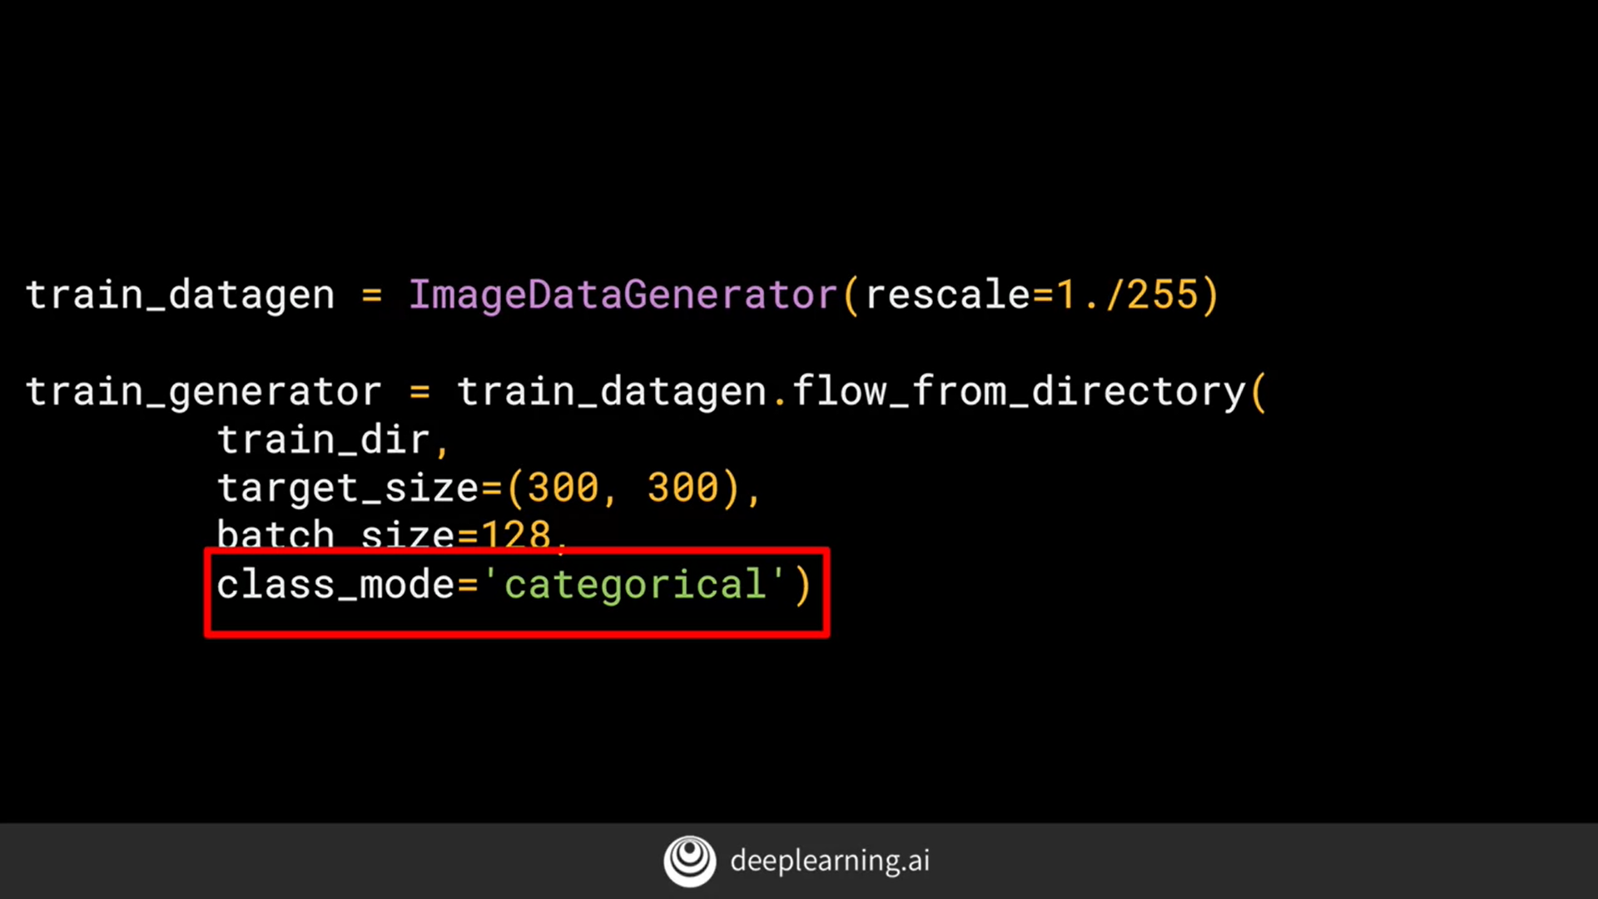

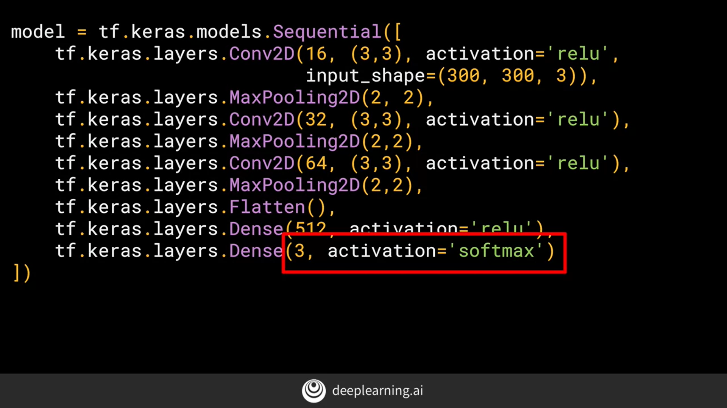

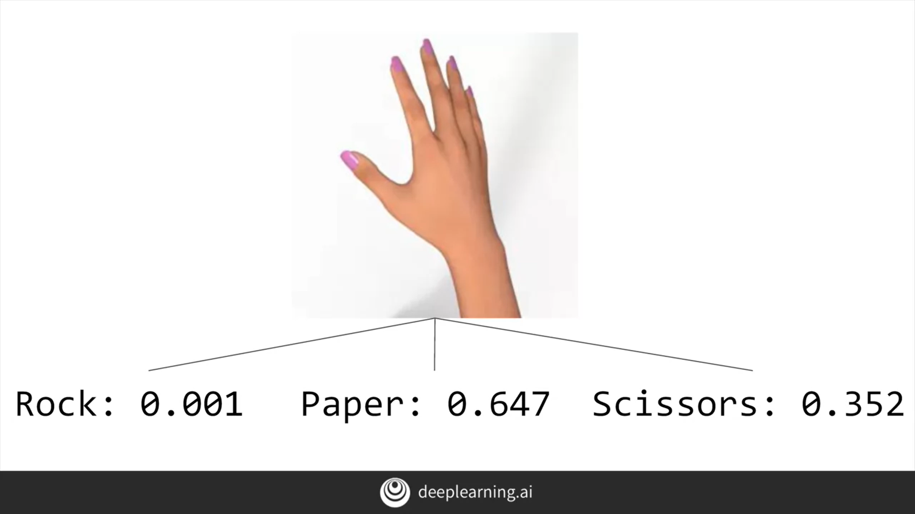

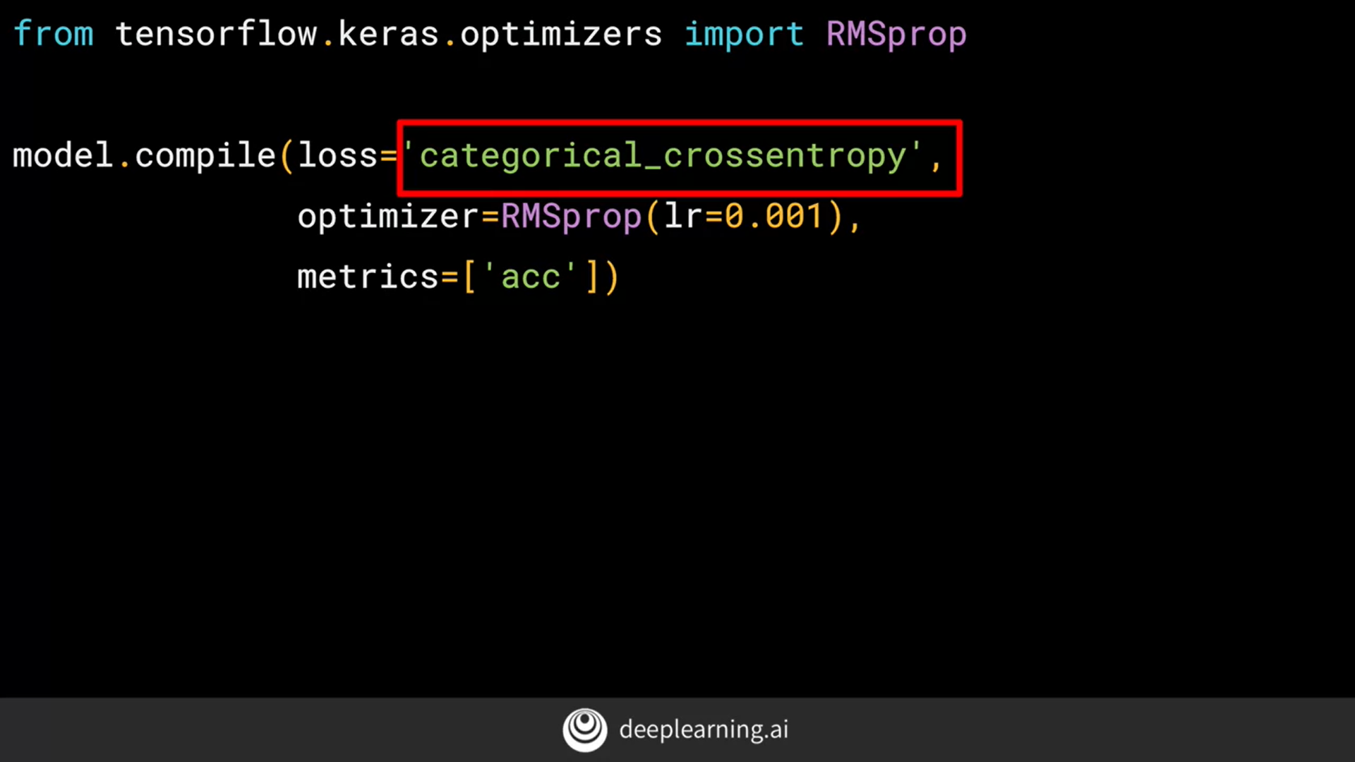

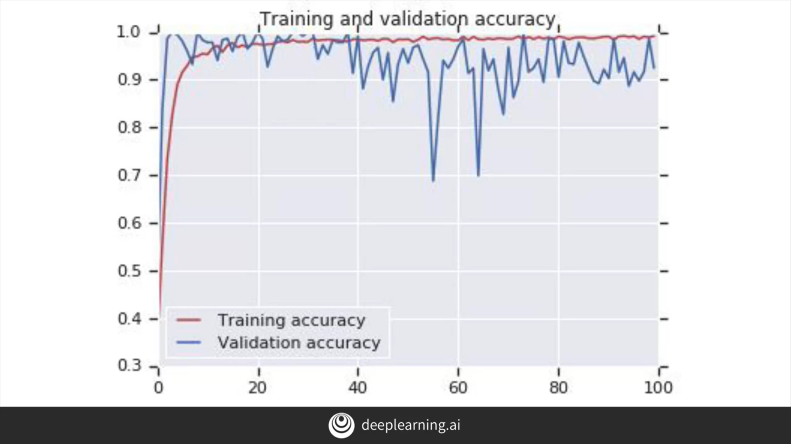

You're coming to the end of Course 2, and you've come a long way! From first principles in understanding how ML works, to using a DNN to do basic computer vision, and then beyond into Convolutions.

With Convolutions, you then saw how to extract features from an image, and you saw the tools in TensorFlow and Keras to build with Convolutions and Pooling as well as handling complex, multi-sized images.

Through this you saw how overfitting can have an impact on your classifiers, and explored some strategies to avoid it, including Image Augmentation, Dropouts, Transfer Learning and more. To wrap things up, this week you've looked at the considerations in your code that you need for moving towards multi-class classification!

IMP - ValueError: You are passing a target array of shape (64, 1) while using as loss `categorical_crossentropy`. `categorical_crossentropy` expects targets to be binary matrices (1s and 0s) of shape (samples, classes). If your targets are integer classes, you can convert them to the expected format via:

```

from keras.utils import to_categorical

y_binary = to_categorical(y_int)

```

Alternatively, you can use the loss function `sparse_categorical_crossentropy` instead, which does expect integer targets.